CSG1105 Assignment 2 – Network Implementation

Background
Widgets and Gadgets (WaG) have recently acquired a business, We Make Stuff (WMS), in another city. Before work can commence on integrating WMS's network into WaG's, WMS actually need to have a network. WMS consists of three close buildings, each with multiple floors. Each floor is dedicated to a business function as defined in this network design topology.

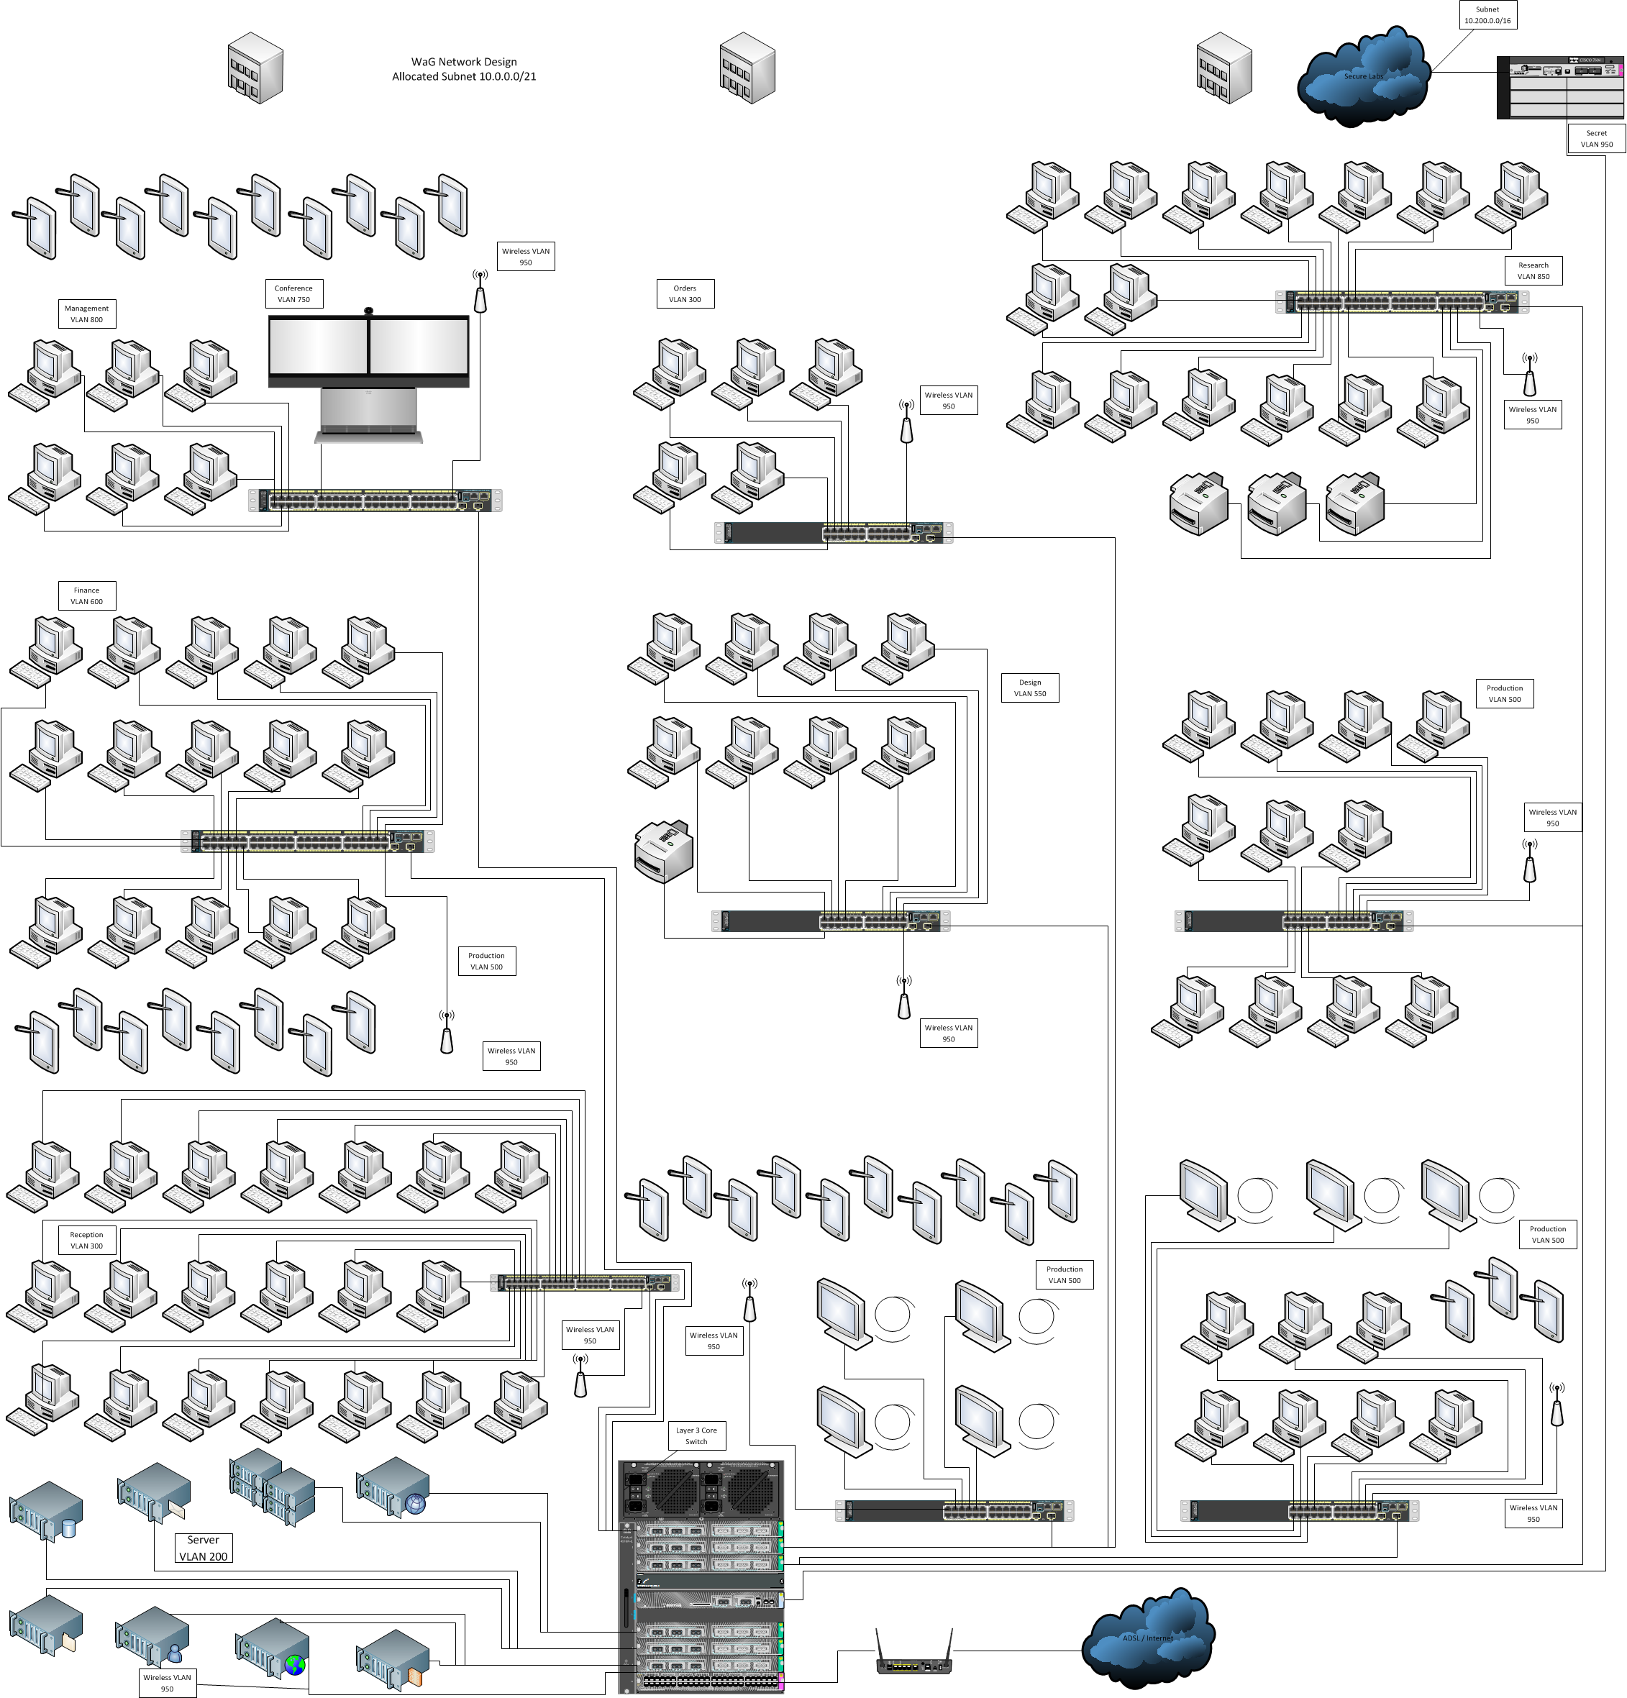

Task Details
You have been given the final design approved by the tender process and hired to implement that design. In this submission you should take the design given and implement it in Packet Tracer. Where there is ambiguity, you are encouraged to use your best judgement. The design includes several VLANs, a Routing Layer 3 switch and 2 routers to external networks. There is a Wirelss VLAN that all wireless access points and the VPN server connect to.

Remember, this is an implementation. Transferring logical concepts into practical application needs to be displayed, physical implementation of logical processes such as subnetting are important. You have been given the Network range of 10.0.0.0/21 to work with. Good luck Network Warrior!

Marks Worth 25% of the total marks of the unit
Due Date Week 11 (exact date listed on Blackboard)

Submission Instructions
Submit the Packet Tracer file only through Blackboard. Include an MD5 hash in the comments section; this is for your benefit if there are problems with Blackboard.

The marking allocation for this assignment is at the end of this document. If any point is unclear send an e-mail, phone or make an appointment well before the assignment is due with your lecturer.

Plagiarism
Please ensure that you have read and understood the information on plagiarism provided on the site for this unit and read the Academic Misconduct Rules. Should you not reference correctly or be caught copy or plagiarising others work the penalties for this are mandatory and serious. Repeat offences in other units may result in course termination. If you are unsure consult with your lecturer or the Faculty Academic Skills Adviser before submitting your work for assessment.

CSG1105 Assignment 2

Marks Allocation
Logical Topology Implemented | 7
VLANs correctly implemented | 5
Subnetting done appropriately | 7
Routing works correctly | 4
Secret Department handled appropriately | 2

